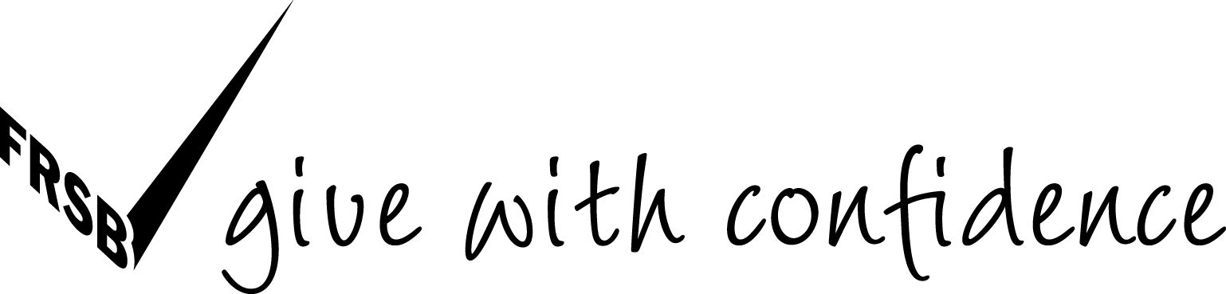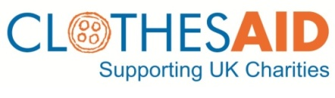

PRESS RELEASE: 5th December 2012
FOR IMMEDIATE RELEASE
Proceeds of Crime Act used to seize money from charity bag fraudster

Clothes Aid would like to report that a substantial amount of cash has been successfully seized from a man involved in charity bag fraud. Igors SOBOLEVS, who had been living in Dublin had the money totaling around £78,000 seized under the Proceeds of Crime Act at Folkestone Magistrates Court, on 29th June 2012.

Clothes Aid had initially learnt of a fake charity “Robin Hood Charity” that was being used by a company called DHJ Textiles to solicit donations; Sobolevs was a director of DHJ at the time it was being used to dupe donors in the UK. Robin Hood was not, or never had been registered with the Charity Commission therefore Clothes Aid duly alerted the Police and other agencies including HMRC (now UKBA) and Trading Standards.

Sobolevs was stopped with the money hidden around his car and person and could not prove its provenance, therefore the Magistrates at Folkestone ordered the cash to be seized as the proceeds of crime. Sobolevs appealed for its return to Maidstone Crown Court but did not show up to defend his claim, therefore the money will not be returned.

The case was connected to arrests made in Rainham, Essex, where six men were arrested by the Metropolitan Police. Following those arrests, Arnas Gasuinas, was sentenced on four counts of handling stolen charity donations at Basildon Crown Court, on Christmas Eve 2011. A suspect lorry present when police arrested Gasiunas, contained bags from the fake charity “Robin Hood”.

Gasiunas was sentenced to three years in prison and Sobolevs has lost his ill-gotten gains which, from Clothes Aid’s point of view, sends out the message that this type of crime will not be tolerated, with police authorities up and down the country cracking down.

Clothes Aid really welcome this action as it sends a clear warning to bogus collectors and thieves that if you steal from, or try to defraud charity you will be caught says Michael Lomotey, Head of Collection Protection at Clothes Aid. Criminals that aim to deprive charity of much needed donations are being targeted by the authorities and these punishments will act as a deterrent. The public can be reassured that those who commit wrong-doing will not benefit. Clothes Aid will continue to work with the Police and other Agencies such as UKBA and Trading Standards to tackle those involved.

Clothes Aid gives the following advice for people wanting to donate to charity from their doorstep:

- Always look for the Fundraising Standard Board’s (FRSB) ‘Give with Confidence’ tick logo
- Look for a registered charity number and, if in doubt, check on the Charity Commission website: www.charity-commission.gov.uk
- Look for a landline number and try calling the number. Clothes Aid’s Helpline answers over 20,000 calls each year and is open Monday to Friday 9am-5pm: 08450 722 780
- Legally, charity bags must say how much they will give to charity per tonne. This is another notification on charity bags of which to take note
- You can also collect clothes for charity through Clothes Aid’s Charity Champions’ scheme. For more details, visit http://clothesaid.co.uk/specialcollections/charity-champions/
For more information, please contact: Michael Lomotey, Clothes Aid, on 020 7288 8536, 07951 317 519 or mlomotey@clothesaid.co.uk.

NOTES TO EDITORS:
Clothes Aid was started in 1996 and is the largest commercial clothing collection company in the UK. It is a social business meaning that profits are sent to the charity partners it works with or are reinvested in the business for further growth
Clothes Aid is a fully-licensed fundraiser compliant with all UK Charity Commission regulations concerning the collection and sale of used clothing
Clothes Aid works very closely with police from various authorities, other legitimate clothing collection companies and partner charities to crack down on bogus collectors and sits on the City of London Police’s charity fraud resource desk
Look for the “Give with Confidence‟ tick of approval from the Fundraising Standards Board (FRSB) on leaflets and bags. Reputable clothing collection businesses and genuine charities are likely to be members of the Fundraising Standards Board, an independent self-regulatory body for UK fundraising, backed by the Office for Civil Society, The Scottish Government and the Welsh Assembly Government. The FRSB tick is now seen by the public 50 million times a year. It is the stamp of reassurance for members of the public thinking of donating to charity

