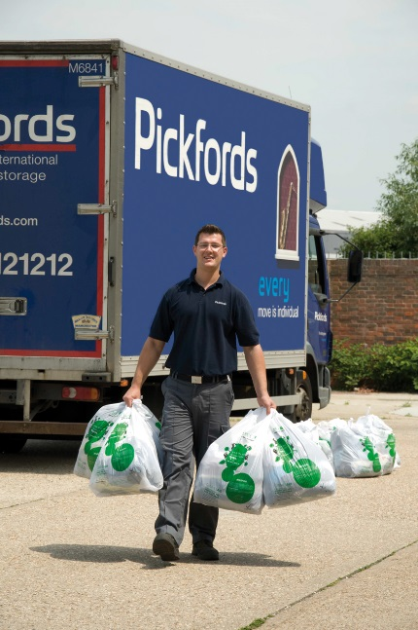

June 2014: Pickfords Move Day Clothes Clear Out campaign for the NSPCC

Calling all home movers! If you’re in need of a reliable and socially responsible removals company, look no further. Clothes Aid, official clothes collection partner to the NSPCC, is supporting the official launch of Pickfords Move Day Clothes Clear Out campaign raising funds to stop cruelty to children in the UK.

Pickfords has been moving homes for generations and can ensure that every aspect of your move goes just how you want it to. The Move Day Clothes Clear Out campaign is a feature that Pickfords has now fully integrated into their service which costs the customer nothing and provides a simple way to donate quality, reusable clothing, paired shoes, accessories, soft toys, books and CDs to charity on move day. Your move consultant will provide you with NSPCC Clothes Clear Out stickers leaving you to bag up anything you don’t want taken to your new abode. The removals team take the stickered bags for Clothes Aid to then collect and turn into money for the NSPCC.

Clothes Aid strive to make it hassle free for the public to donate unwanted clothing and home textiles, so that charities can benefit financially without costing them a penny. Did you know that there’s approximately £140 million of clothing going to landfill in the UK every single year, equivalent to 350,000 tonnes of good clothing being binned by half the adults in the UK*. So when it comes to clothes collections, we believe that doing our bit for the environment is equally important. Which is why we are a proud signatory of a new initiative called Love Your Clothes which aims to change the way we acquire, use and dispose of textiles, by 2020. And campaigns like Move Day Clothes Clear Out are steps in the right direction.

Since the start of this successful relationship with Clothes Aid, Pickfords customers have raised £11,000 for the NSPCC. That’s enabled Childline to answer 2,750 calls from vulnerable children in need of a voice. With your help, we can raise even more.

With approximately 30% of clothes in each household unworn for over a year, what better way to lighten the load before a big move, lower our impact on the planet and support NSPCC’s plight to end cruelty to children.

Let’s keep Britain moving with Pickfords and donate to the NSPCC!

Coming soon… Don’t miss your chance to win a FREE** move courtesy of Pickfords Clothes Clear Out!

For Clothes Aid press enquiries, please contact Emma O’Leary on 020 7288 8528 or eo'leary@clothesaid.co.uk. For more information regarding collections, please call the Clothes Aid helpline on 020 7288 8545 or www.clothesaid.co.uk. Follow us on Twitter (@ClothesAid) and ‘like’ us on Facebook (Clothes Aid) to show your support to our UK partner charities.
Notes to Editor:
*WRAP report, Valuing our Clothes, 2012
** To be featured in Metro UK, Friday 27th June 2014. Free move up to the value of £1,000, not including goods in transit insurance.
Clothes Aid is a fully licensed fundraiser, compliant with all UK Charity Commission regulations concerning the collection and sale of used clothing. Founded in 1996, Clothes Aid is now one of the largest commercial clothing collection companies in the UK who pride themselves on being fully transparent and follows industry and sector Best Practice at all times. Clothes Aid is a social business that requires zero investment from charity partners with each charity receiving a contractually agreed percentage of profit, which resides between 84-95%, depending on each charity’s licences and collection overheads. The modest profit remaining is reinvested to aid growth to generate more funds for charities. Clothes Aid collection teams are fully uniformed, carry ID cards with fully branded livery and collects from over 45,000 households every week across the UK. Clothes Aid fundraise for some of the biggest UK charities, including NSPCC, Make-A-Wish Foundation UK, Macmillan Cancer Support, Children’s Hospice Association Scotland and other regional charities, and has raised over £8 million. Clothes Aid bags carry the ‘Give with Confidence’ tick of approval from the Fundraising Standards Board, a stamp of reassurance for members of the public thinking of donating to charity. Working closely with WRAP, Clothes Aid have signed up to a commitment to measure and report the environmental ‘footprint’ of clothing throughout its life, and to take action to reduce the impact by 2020. The Love Your Clothes branding forms part of this awareness campaign.
The NSPCC has one vision, to end child cruelty in the UK and since 1884, has helped more than 10 million children in the UK. The NSPCC is focused on helping children who are in the greatest danger and distress, as well as support services such as 24 hour helplines, general enquiries, community projects, specialist advice and information for adults and professionals in order to help them protect children. Clothes Aid has been the official clothes collection partner to the NSPCC since 2009 and has raised over £3.1 million. NSPCC receive £300 for every tonne donating through the Move Day Clothes Clear Out campaign. NSPCC is a registered charity in England & Wales (216401) and Scotland (SC037717) via the NSPCC Trading Company Ltd. If you’re worried about a child, don’t wait until you’re certain. Contact the helpline on 0808 800 5000. If you're a child and you have any worries you can call ChildLine on 0800 1111.For more information or to see the various ways you can get involved, visit nspcc.org.uk

