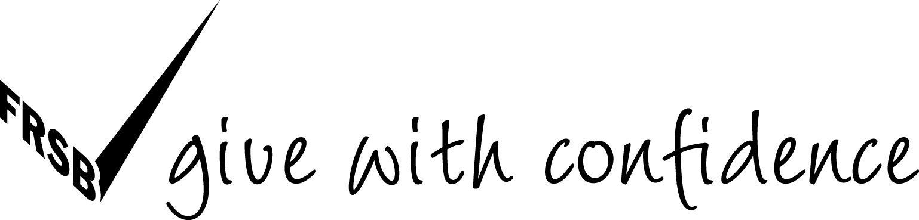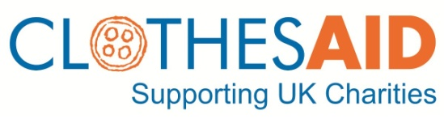

PRESS RELEASE
25 Sep 2011
FOR IMMEDIATE RELEASE

Institute of Fundraising Scotland launches ‘Give With Care’ campaign

The Fundraising Standards Board (FRSB) and the Institute of Fundraising Scotland (IoFS) are coming together to launch a ‘Give With Care’ campaign in Scotland this week, urging the public to be careful when donating clothing and unwanted goods to charity. The campaign alerts the public to bogus collectors – a problem that is estimated to cost UK charities up to £50 million a year in lost income.

Clothing and textiles is the fastest growing area of household waste at around 2 million tonnes per annum. Of this, as much as 1.2 million tonnes ends up in landfill, which could be avoided.

Charity collections are an important way of not only reducing waste and preserving our environment but of generating vital funding. Clothing collections raise an estimated £250 million for UK charities each year. Some charities collect goods themselves, others – particularly smaller charities and those without the necessary infrastructure or reach – use commercial participators to collect on their behalf.

The ‘Give With Care’ campaign highlights the need to keep on donating goods, advising the public of a few simple checks they can make to ensure they are donating to legitimate charity collections. Supported by Clothes Aid, 180,000 leaflets will be delivered to households across Scotland over the next three weeks. The campaign also engages the support of Members of the Scottish Parliament (MSPs) in delivering this important message to residents in their constituencies.

The ‘Give With Care’ campaign offers this advice for the donating public:
- Keep giving - beneficiaries need you to donate goods that charities can sell on. Use the following checks before you give to doorstep collectors
- Check - legitimate charitable collectors will display a Scottish charity number on their literature- it begins with SC0. The Office of the Scottish Charity Regulator will be able to confirm if a collector is working on behalf of a registered charity - www.oscr.org.uk and 01382 220446
- Check again - look for the FRSB’s “tick” logo showing the charity has signed up to high standards and regular monitoring
- Phone: a legitimate collector would leave a working telephone number for you to check they are collecting in your area
- Some collectors may not be registered charities but still collect for legitimate good causes in your area. Bogus collectors will often promote vague causes rather than specific charities or local good causes

Criminal activity around charity doorstep collections lies in two camps: theft of bags and bogus or fraudulent collections that falsely claim to be raising money for charitable causes. The National Fraud Intelligence Bureau (FRIB) affirms that bogus collections are carried out by organised criminals, with links to money laundering, human trafficking and serious violent offences. Both charity bag theft and bogus collections have increased substantially in recent years.

In one recent sample of charity bags, the Charity Retail Association reported that as many as 10% were found to be bogus.

Alistair McLean, Chief Executive the Fundraising Standards Board, says:
“We have seen a 100% increase in complaints about bogus goods collections over the past year as supporters query suspicious collections and express their confusion about which collections are legitimate. The problem has now become so widespread that charities are losing many millions each year and public confidence in this form of giving has taken a battering. It is crucial to protect this income stream for charities, reassuring the public that they can give confidently to the charities they care about and how, with some simple checks, they can make sure that their donations are going just where they want them to.”

Gregor McNie, Scotland Manager, Institute of Fundraising , says: “We’re committed to doing everything in our powers to tackle bogus collectors. Clothing collection is a fantastic growing income stream for charities that is being exploited by bogus collectors. These bogus collectors can not only eat into this income but also negatively affect public trust in charities. This campaign aims to go all across the country with the simple messages of keep on giving and give with care.”

Sponsoring the campaign, Michael Lomotey, Business Manager of Clothes Aid, adds: “Clothing collections are a great source of income for charities such as the Children’s Hospice Association Scotland (CHAS) and a convenient way for the public to give a non-financial contribution. That is why Clothes Aid is really pleased to support the Institute of Fundraising Scotland and the Fundraising Standards Board in urging households to continue to give on the doorstep, but to ‘Give With Care’. Reputable clothing collection businesses and genuine charities are likely to be members of the FRSB so look for the ‘Give with confidence’ tick of approval on leaflets and bags. Don’t let bogus collectors steal your charity spirit and help stop bogus collectors from capitalising on good causes.”

For further information, visit www.givewithconfidence.org.uk and www.institute-of-fundraising.org.uk
ENDS
MEDIA ENQUIRIES
For interviews with Michael Lomotey from Clothes Aid or for images, please contact:
Jo Moulds, Press & PR Officer, on 020 7288 8538, 07983 514122 or jmoulds@clothesaid.co.uk or Michael Lomotey, Business Manager, on 020 7288 8536 or mlomotey@clothesaid.co.uk.

NOTES TO EDITORS
- The Fundraising Standards Board (www.frsb.org.uk) is the independent self-regulatory body for UK fundraising. Launched in 2007, the FRSB commits members to the highest standards of fundraising practice, encouraging donors to ‘Give with confidence’. The scheme logo, displayed by all members, is a public commitment to best fundraising practice, to being honest, transparent and accountable in their fundraising activities. Members abide by
The Fundraising Promise and the Institute of Fundraising’s Codes of Fundraising Practice. Fundraising complaint levels are monitored and published annually by the FRSB
- The Institute of Fundraising Scotland is the representative body for fundraisers and fundraising in Scotland and part of the UK-wide Institute of Fundraising. In Scotland, the Institute represents over 500 individuals covering a broad range of Scottish voluntary and community organisations and provides training, networking and representation on fundraising issues. It acts as an interface with the public, media and sector stakeholders, developing policy in the voluntary sector arena and reacting swiftly to issues affecting the fundraising environment in Scotland
- The Institute of Fundraising’s (www.institute-of-fundraising.org.uk) mission is to support fundraisers, through leadership, representation, standards setting and education, to deliver excellent fundraising. Members are supported through training, networking, dissemination of best practice and representation on issues that affect the fundraising environment. The Institute of Fundraising is the largest individual representative body in the voluntary sector with 5000 Individual members and 330 Organisational members
- Clothes Aid (www.clothesaid.co.uk) was started in 1996 and is the largest commercial clothing collection company in the UK. It is a social business meaning that all profits are sent to the charity partners it works with or are reinvested in the business for further growth

