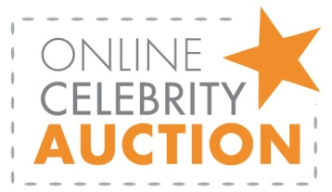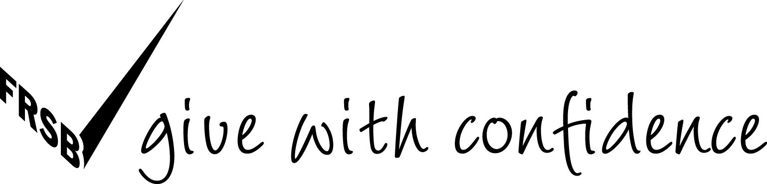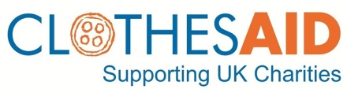

PRESS RELEASE FOR IMMEDIATE RELEASE: 26.10.11

Jeff Banks urges UK to Set Their Clothes Free – as Clothes Aid launches celebrity online auction
Did you know we all have approximately 22 items of unworn clothing lurking at the back of our cupboards?*
This week, Clothes Aid, the UK’s largest clothes collection company on behalf of charities, launches an online auction offering people the chance to bid their unwanted clothes to win celebrity fashion finds. The pieces have been donated via charity partners including the NSPCC, Make-A-Wish Foundation® UK and the
Noah’s Ark Appeal. First up for grabs will be an original, cult Clothes Show television programme puffer jacket from Jeff Banks and a new item will appear on the website every Monday for the next three weeks.
Celebrities who have donated clothes include Charlotte Church, who has donated a Vivienne Westwood dress on behalf of the Noah’s Ark Appeal, Cardiff, as well as Laura Hamilton, Dancing on Ice and C4’s
new A Place in the Sun presenter, who has donated a stunning off-the-shoulder cream dress on behalf of
Make-A-Wish.
Members of the public are being asked to outbid each other by pledging no longer wanted items of clothing at www.clothesaid.co.uk/specialcollections/celebrity-auction. The person who donates the most items of clothing will win the celebrity fashion piece for their own wardrobes, and the clothes will then be sold by Clothes Aid to raise much-needed funds for the chosen charity.
Paul Amadi, Director of Fundraising at the NSPCC, says:
”This celebrity charity auction is a great way of getting people involved in clothing collections. The funds raised by members of the public who donate their unwanted clothes are invaluable to the NSPCC’s work.
Our partnership with Clothes Aid has already made over £1.9m, which will help the NSPCC to continue to support and protect vulnerable children in the UK.”
Cont.

Karen England, Director of Fundraising at Make-A-Wish, comments:
“Set Your Clothes Free is a fantastic initiative which we hope will really highlight the benefit of clothing collections. Since we started working with Clothes Aid in 2007, over £600,000 has been raised for
Make-A-Wish. This has helped us grant more than 150 wishes so it really is an extremely valuable resource for us.”
Suzanne Mainwaring, Director of the Noah’s Ark Appeal, says:
”We are thrilled to be a part of the Set Your Clothes Free initiative. The celebrity clothing auction is a fantastic way to draw attention to the importance of clothing collections, and we hope to attract many Clothes Aid Charity Champions in our community.”
The auction celebrates the launch of a new service from Clothes Aid called Charity Champions.
Charity Champions is a network of volunteers who collect good-quality clothes, shoes and accessories,
still in wearable condition, from friends, family and colleagues a few times throughout the year in order to raise funds for Clothes Aid charities.
Clothing collections provide a valuable source of income for charities and Clothes Aid gives over £1.4 million to UK charities every year. Clothes Aid can sell any clothes that are given but the money received varies depending on their quality. The idea of Charity Champions is that by encouraging people to give better quality clothing, Clothes Aid can raise even more money for its charity partners.
People who miss out on the auction can still support Clothes Aid charities by filling a bag and giving clothes. Either fill a Clothes Aid bag delivered to your door for collection by a Clothes Aid uniformed collector or sign up to become a Charity Champion and help people in your community raise money for charity, without having to give a monetary donation. For more about Clothes Aid Charity Champions, visit www.clothesaid.co.uk/specialcollections/charity-champions.
-ENDS-

* According to research conducted in 2011 by the television online retailer, QVC.

NOTES TO EDITORS:
- Clothes Aid was started in 1996 and is the largest commercial clothing collection company in the UK. It is a social business meaning that profits are sent to the charity partners it works with or are reinvested in the business for further growth

- Clothes Aid is a fully-licensed fundraiser compliant with all UK Charity Commission regulations concerning the collection and sale of used clothing
- Clothes Aid works very closely with police from various authorities, other legitimate clothing collection companies and partner charities to crack down on bogus collectors and sits on the
City of London Police’s resource desk
- If you suspect a bogus collector or a theft you can call the Collection Protection helpline on
020 7288 8535. Try to note down a description of the individual or group, the time and place of the incident and any other relevant details to share with the helpline staff
- Look for the ‘Give with Confidence’ tick of approval from the Fundraising Standards Board (FRSB)
on leaflets and bags. Reputable clothing collection businesses and genuine charities are likely to be members of the Fundraising Standards Board, an independent self-regulatory body for UK fundraising, backed by the Office for Civil Society, The Scottish Government and the Welsh Assembly Government. The FRSB tick is now seen by the public 50 million times a year. It is the stamp of reassurance for members of the public thinking of donating to charity
- The terms and conditions for the celebrity auction are: Only one entry per household but more
than one member of a family can add to the bid (ie you can keep increasing your bid by watching the auction). You will be notified of your success in winning the auction within 30 days of the auction ending by post or email. We apologise that those who don’t win the auction will not be notified individually.
- Timings of auction:
  - Auction 1 - Jeff Banks
Starts: Mon 24.10.11 / Ends: Sat 5.11.11
  - Auction 2 - Laura Hamilton
Starts: Mon 31.10.11 / Ends: Sat 12.11.11
  - Auction 3 - Charlotte Church
Starts: Mon 7.11.11 / Ends: Sat 19.11.11

For more information, please contact: Jacqueline Culleton, Forster PR, on 020 7403 2230 or Jacqueline@forster.co.uk or Jo Moulds, Press & PR Officer, Clothes Aid, on 020 7288 8538, 07968 801467
or jmoulds@clothesaid.co.uk.

